How to obtain API Key
- Go to biz.zygy.com
- Register or login into an account
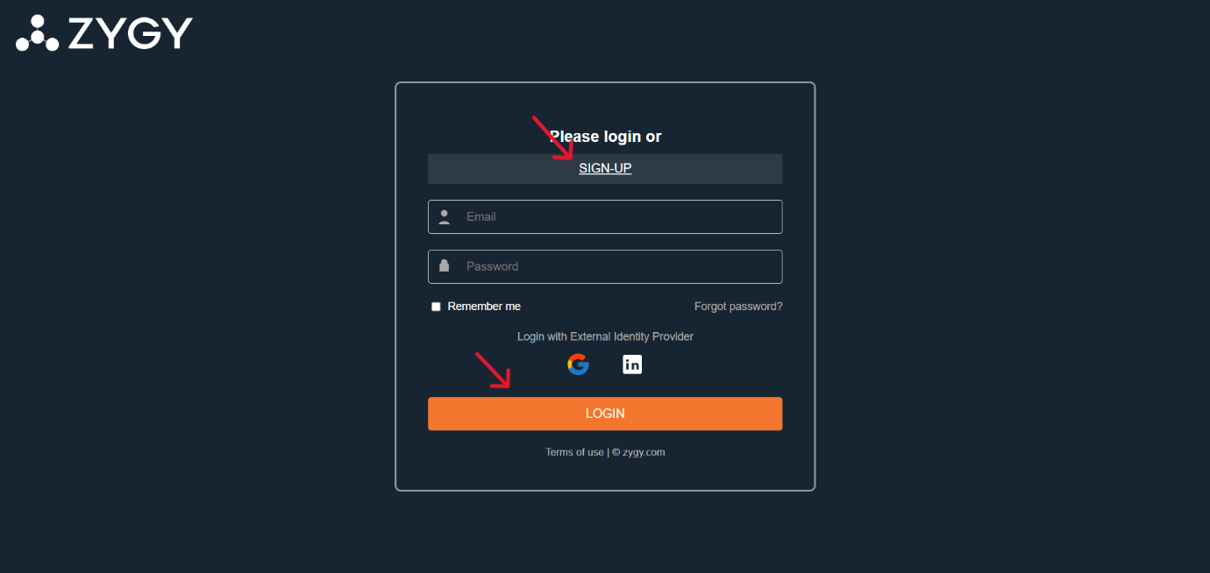

- Click on the profile icon positioned at top right, and click on Admin tab
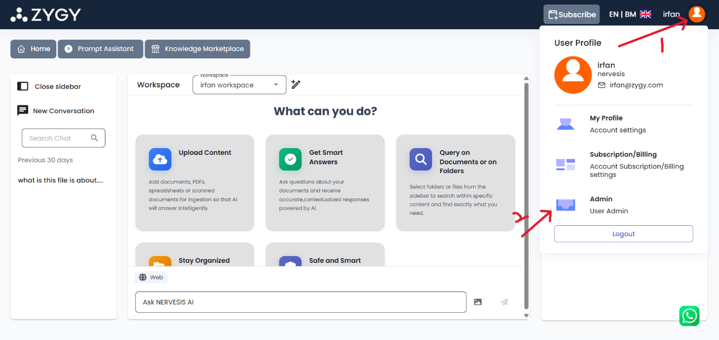

- Click on Manage API Key tab, and you can click ‘Create New Secret Key’ button to create an API Key
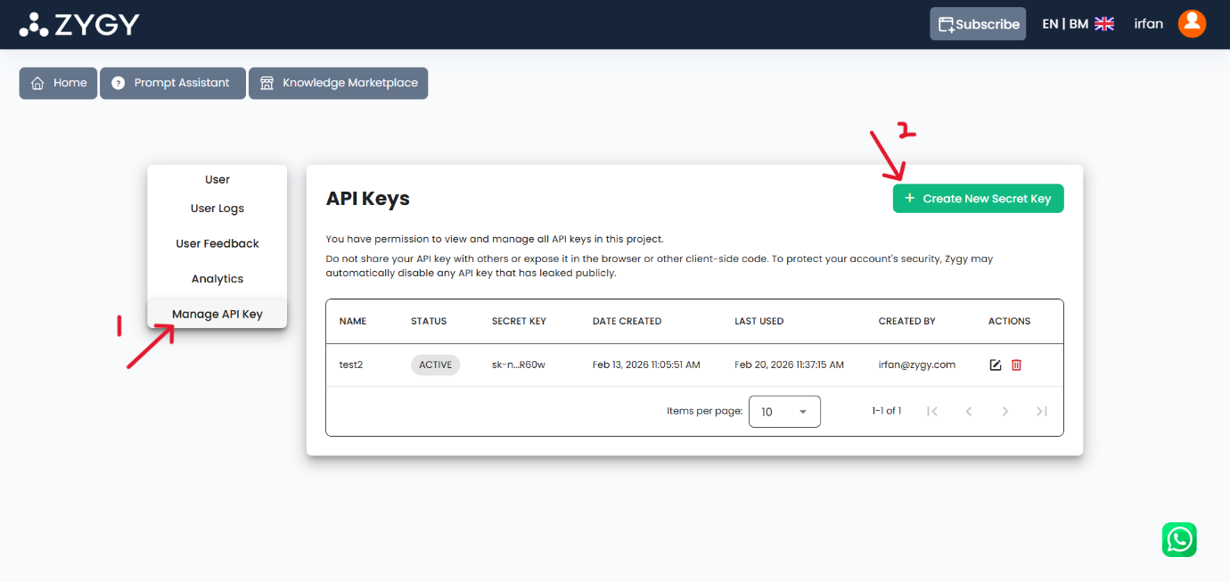
- Give a name to your Secret Key
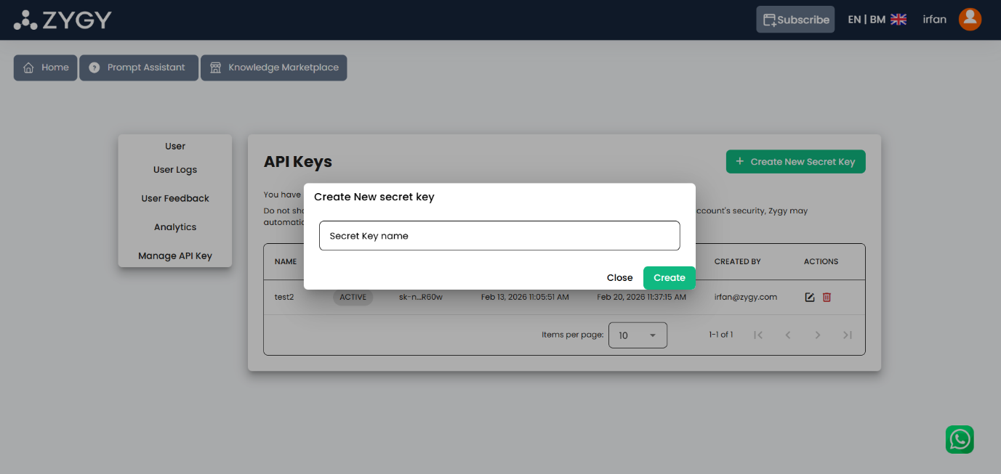

- Ensure you copy and save the key as it will not be shown anymore
